

Ashley Furniture Industries, LLC. - Ashley Distribution Services, Ltd. - Ashley

IT Application Document
Expired specials discount removal

Project Title : Expired Specials discount removal
Dev Ops Epic:
Dev Ops Epic Link:
Dev Ops Feature:
Dev Ops Feature Link:

Version: [Enter Version Number]

Revision History

Version # | Change Implementation Date | Detailed Description | Change Request Number | Reference Section page Number | Author
1.0
1.1
1.2

Table of Contents
Revision History 2
1 Introduction 6
1.1 Overview and Background 6
2 Navigation Steps 6
2.1 Menu Option or Scheduled Tasks 6
2.2 Screenshots, report examples and any applicable description 6
3 Application Functionality 7
3.1 Application Information 7
3.2 Functional Flowchart 8
3.3 Business Rules 8
4 Application Functionality 8
4.1 Technical Flowchart 8
4.2 Field Population Rules 8
4.3 Application Configuration 9
4.3.1 General Application Settings 9
4.3.2 Azure Application Settings 9
4.3.3 Azure Key Vault Settings 9
4.3.4 Azure Service Bus Configuration 9
4.3.5 Azure Storage Configuration 9
4.4 Control Table Configuration 9
4.4.1 Server Name 9
4.4.2 Table Name 9
4.4.3 Table Design and Description 9
4.4.4 Control Values 9
4.5 Audit Table 10
4.5.1 SQL Server Name 10
4.5.2 Database 10
4.5.3 Table Name 10
4.5.4 Table Design and Description 10
4.6 Log Table 10
4.6.1 SQL Server Name 10
4.6.2 Database 11
4.6.3 Table Name 11
4.6.4 Table Design and Description 11
4.7 Application Table 11
4.7.1 SQL Server Name 11
4.7.2 Database 11
4.7.3 Table Name 11
4.7.4 Table Design and Description 11
5 Dependencies 12
5.1 Assembly 12
5.2 Packages 12
5.3 API’s 12
6 Technical Details 12
6.1 Stored Procedures 12
6.2 BI Report 12
6.3 Programs 12
6.4 User Interface 12
6.5 Output 12
6.6 Email Notifications 12
7 Unit Testing 12
7.1 Preparation for Unit Testing 13
7.2 Test Cases for Unit Testing 13
8 QA Testing 13
8.1 QA Test Cases 13
(Add Azure dev ops Link) 13
9 UAT Testing Preparation 13
9.1 UAT Demo - Test Scenario 13
10 Implementation to Prod 13
10.1 Implementation Checklist 13
10.2 Change Request Template (If available) 13
11 Appendixes 13
12 Glossaries 13

How to Update the Table of Contents:
- Click anywhere in the Table of Contents to select it (it becomes grayed when selected).
- The Update Table dialog box appears in the upper left corner of the table:
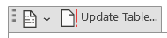
- Click on Update Table and The Update Table of Contents dialog box appears:
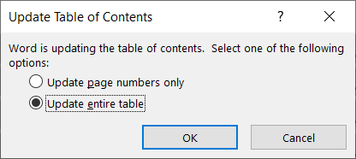
- Choose Option 1 to Update page numbers only if none of the headings have changed, but just the page numbers; OR choose option 2 to Update the entire table if more substantial changes were made to your document – such as headings that were added or removed, or additional paragraphs that were formatted with heading styles for inclusion in the Table of Contents.
- Click OK.

Introduction

Overview and Background
The Expired Special Discount Removal functionality provides an automated workflow for identifying, reviewing, and removing expired promotional discounts from the order. It includes a defer list mechanism to allow exceptions for discounts that should not be automatically removed.

Navigation Steps

Menu Option or Scheduled Tasks
AshleyNet-> Filemaintenance -> Order Maintenance -> Expired special Discounts
AshleyNet-> Filemaintenance -> Order Maintenance -> Expired special defer list

2.2 Screenshots, report examples and any applicable description

A special discount is flagged as expired when the user modifies the requested date to a date that exceeds the discount's "must ship by" date. Once identified as expired, the Pricing team will remove these discounts from the order.

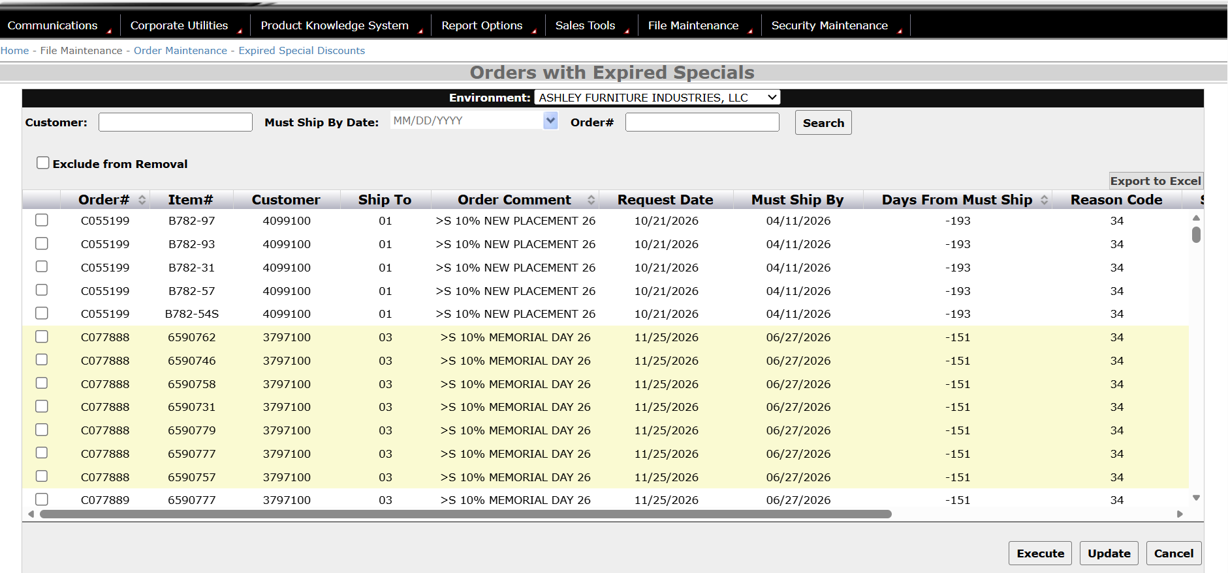

If Pricing team needs to allow exceptions for specific discounts that should not be automatically removed, they can configure these exceptions in the Expired Special Defer List application. This application maintains a list of discounts that are exempt from automatic removal.

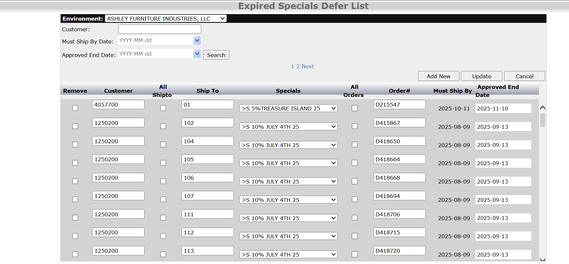

Application Functionality

A special discount is flagged as expired when the user modifies the requested date to a date that exceeds the discount's "must ship by" date. Once identified as expired, the Pricing team will remove these discounts from the order.
In cases where the Pricing team needs to allow exceptions for specific discounts that should not be automatically removed, they can configure these exceptions in the Expired Special Defer List application. This application maintains a list of discounts that are exempt from automatic removal.

3.1 Application Information

3.2 Functional Flowchart
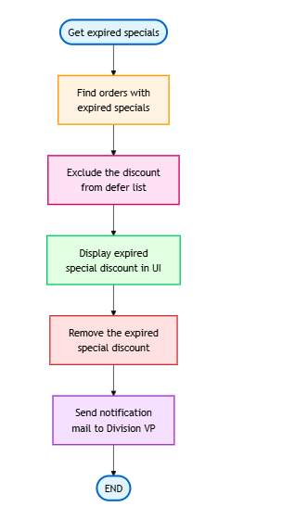

Business Rules
Ashley Furniture runs numerous time-limited promotional discounts. These promotions discount will be consider as expired incase the requested date changed beyond the specials discount “must ship by date” after order creation

Application Functionality

4.1 Technical Flowchart

4.2 Field Population Rules

Application Configuration

General Application Settings

Azure Application Settings

4.3.3 Azure Key Vault Settings

4.3.4 Azure Service Bus Configuration

4.3.5 Azure Storage Configuration

4.4 Control Table Configuration

4.4.1 Server Name
Environment | Server Name
Dev | aazeud-afidsq01\AFI_DDYNAMIC
Stage | aazeus-afidsq01\AFI_QDYNAMIC
Prod | AE1DCVPSQ23827\SQL_DYNAMIC

4.4.2 Table Name
Table Name
tblExpiredSpecials
tblExpiredSpecialsDeferList

4.4.3 Table Design and Description

4.4.4 Control Values

4.5 Audit Table
[Example: “All user changes are logged in an audit table, TaskSchedulerRunlog. Also if an error or exception occurred on the performed action, it will be logged in this same audit table, TaskSchedulerRunlog.”]

4.5.1 SQL Server Name
Environment | Server Name
Dev | aazeud-afidsq01\AFI_DDYNAMIC
Stage | aazeus-afidsq01\AFI_QDYNAMIC
Prod | AE1DCVPSQ23827\SQL_DYNAMIC

4.5.2 Database

4.5.3 Table Name

4.5.4 Table Design and Description

4.6 Log Table
[Example: “All the transactions performed during a task are logged in an log table, TaskSchedulerRunlog. Also if an error or exception occurred on the performed action, it will be logged in this same Log table]

4.6.1 SQL Server Name
Environment | Server Name
Dev | aazeud-afidsq01\AFI_DDYNAMIC
Stage | aazeus-afidsq01\AFI_QDYNAMIC
Prod | AE1DCVPSQ23827\SQL_DYNAMIC

4.6.2 Database

4.6.3 Table Name

4.6.4 Table Design and Description

4.7 Application Table

4.7.1 SQL Server Name
Environment | Server Name
Dev
Stage
Prod

4.7.2 Database

4.7.3 Table Name

4.7.4 Table Design and Description

Dependencies

5.1 Assembly

5.2 Packages

API’s
Get expired specials discount
https://apicss.ashleyfurniture.com/OrderentryspecialsAPI/ExpiredSpecialsDiscount/GetExpiredSpecialsDiscount
Remove expired specials discount
https://apicss.ashleyfurniture.com/OrderentryspecialsAPI/ExpiredSpecialsDiscount/RemoveExpiredSpecialsDiscount
http://afiprod.ashleyfurniture.com:10010/web/services/PRC_Remove_Expired_Discount

6 Technical Details

6.1 Stored Procedures

6.2 BI Report

6.3 Programs

6.4 User Interface
(Add Applicable screenshots of the application)

6.5 Output

6.6 Email Notifications

7 Unit Testing
[What needs to be in place prior to testing? Provide any steps required to prepare for unit testing, including the staging of any data.]

7.1 Preparation for Unit Testing

7.2 Test Cases for Unit Testing

8 QA Testing

8.1 QA Test Cases

(Add Azure dev ops Link)

9 UAT Testing Preparation

9.1 UAT Demo - Test Scenario
(Add Demo Test cases)

10 Implementation to Prod

10.1 Implementation Checklist

10.2 Change Request Template (If available)

11 Appendixes

12 Glossaries

